Net 1060 Introduction to Networks Lab: # 4.6.5

Name:

Follow the instructions down below for the lab itself. For this lab, all answers need to be in blue font. For the questions right below, answer in complete sentences. Ensure you paste the screen shot of your score page at the bottom of the document. Even if this does not let you see your grade, still take a screen shot of the score page showing congratulations “your name” you have completed the exercise is pasted at the bottom of this document. You will then need to upload both this word document and your packet tracer file to the assignments link within Netacad. Let the instructor know if you have any questions.

Lab Analysis Report

1. Using complete sentences summarize work you completed during the lab.
First, I connected Cloud to Router0 and Cable Modem. Then, I connected Router0 to Router1, Netacad.pka, and Configuration Terminal. Then I connected Router1 to Switch, Cable Modem to Wireless Router, and Wireless Router to Family Pc. Finally I verified the connections between a few of the devices by using the ping tool.

2. Using complete sentences describe what you learned from the lab. Hint; look at the lab objectives listed at the top of the lab section.
In this lab, I learned which cables to use with all the different devices and connections. It took trial and error to figure out which cables went to some of the ports, but I figured it out eventually.

Problems Encountered

1. Using complete sentences describe any problem(s) experienced during lab.
It took me a little bit at first to figure out how to connect the cables to the devices in the logical tab. The instructions weren’t clear how to connect the cables to the ports so I was messing around trying to find the ports in the physical tab.

2. Using complete sentences describe how you solved your problem(s).
I solved this problem by messing around for a little bit and trying to connect cables to different things, then eventually found out that you could just left click the device in the logical tab.

3. Using complete sentences explain if you needed any assistance with the lab; then list what you learned from that assistance.
I didn’t use any assistance to solve the problem; I just used trial and error to figure it out on my own.

Packet Tracer - Connect a Wired and Wireless LAN

Addressing Table
Device | Interface | IP Address | Connects To
Cloud | Eth6 | N/A | F0/0
Cloud | Coax7 | N/A | Port0
Cable Modem | Port0 | N/A | Coax7
Cable Modem | Port1 | N/A | Internet
Router0 | Console | N/A | RS232
Router0 | F0/0 | 192.168.2.1/24 | Eth6
Router0 | F0/1 | 10.0.0.1/24 | F0
Router0 | Ser0/0/0 | 172.31.0.1/24 | Ser0/0
Router1 | Ser0/0 | 172.31.0.2/24 | Ser0/0/0
Router1 | F1/0 | 172.16.0.1/24 | F0/1
WirelessRouter | Internet | 192.168.2.2/24 | Port 1
WirelessRouter | Eth1 | 192.168.1.1 | F0
Family PC | F0 | 192.168.1.102 | Eth1
Switch | F0/1 | 172.16.0.2 | F1/0
Netacad.pka | F0 | 10.0.0.254 | F0/1
Configuration Terminal | RS232 | N/A | Console

Objectives
Part 1: Connect to the Cloud
Part 2: Connect Router0
Part 3: Connect Remaining Devices
Part 4: Verify Connections
Part 5: Examine the Physical Topology

Background
When working in Packet Tracer (a lab environment or a corporate setting), you should know how to select the appropriate cable and how to properly connect devices. This activity will examine device configurations in Packet Tracer, selecting the proper cable based on the configuration, and connecting the devices. This activity will also explore the physical view of the network in Packet Tracer.

Instructions

Connect to the Cloud

Connect the cloud to Router0.
    - At the bottom left, click the orange lightning icon to open the available Connections.
    - Choose the correct cable to connect Router0 F0/0 to Cloud Eth6. Cloud is a type of switch, so use a Copper Straight-Through connection. If you attached the correct cable, the link lights on the cable turn green.

Connect the cloud to Cable Modem.
Choose the correct cable to connect Cloud Coax7 to Modem Port0.
If you attached the correct cable, the link lights on the cable turn green.

Connect Router0

Connect Router0 to Router1.
Choose the correct cable to connect Router0 Ser0/0/0 to Router1 Ser0/0. Use one of the available Serial cables.
If you attached the correct cable, the link lights on the cable turn green.

Connect Router0 to netacad.pka.
Choose the correct cable to connect Router0 F0/1 to netacad.pka F0. Routers and computers traditionally use the same wires to transmit (1 and 2) and receive (3 and 6). The correct cable to choose consists of these crossed wires. Although many NICs can now autosense which pair is used to transmit and receive, Router0 and netacad.pka do not have autosensing NICs.
If you attached the correct cable, the link lights on the cable turn green.

Connect Router0 to the Configuration Terminal.
Choose the correct cable to connect Router0 Console to Configuration Terminal RS232. This cable does not provide network access to Configuration Terminal, but allows you to configure Router0 through its terminal.
If you attached the correct cable, the link lights on the cable turn black.

Connect Remaining Devices

Connect Router1 to Switch.
Choose the correct cable to connect Router1 F1/0 to Switch F0/1.
If you attached the correct cable, the link lights on the cable turn green. Allow a few seconds for the light to transition from amber to green.

Connect Cable Modem to Wireless Router.
Choose the correct cable to connect Cable Modem Port1 to Wireless Router Internet port.
If you attached the correct cable, the link lights on the cable will turn green.

Connect Wireless Router to Family PC.
Choose the correct cable to connect Wireless Router Ethernet 1 to Family PC.
If you attached the correct cable, the link lights on the cable turn green.

Verify Connections

Test the connection from Family PC to netacad.pka.
    - Open the Family PC command prompt and ping netacad.pka.
    - Open the Web Browser and the web address http://netacad.pka.

Ping the Switch from Home PC.
Open the Home PC command prompt and ping the Switch IP address of to verify the connection.

Open Router0 from Configuration Terminal.
    - Open the Terminal of Configuration Terminal and accept the default settings.
    - Press Enter to view the Router0 command prompt.
    - Type show ip interface brief to view interface statuses.

Examine the Physical Topology

Examine the Cloud.
    - Click the Physical Workspace tab or press Shift+P and Shift+L to toggle between the logical and physical workspaces.
    - Click the Home City icon.
    - Click the Cloud icon.

Question:
How many wires are connected to the switch in the blue rack?
There are 3 wires in total., 2 Network and 1 power wire.
Type your answers here.
    - Click Back to return to Home City.

Examine the Primary Network.
    - Click the Primary Network icon. Hold the mouse pointer over the various cables.

Question:
What is located on the table to the right of the blue rack?
On the table to the right is Configuration Terminal.Type your answers here.
    - Click Back to return to Home City.

Examine the Secondary Network.
    - Click the Secondary Network icon. Hold the mouse pointer over the various cables.

Question:
Why are there two orange cables connected to each device?
Router1 has two cables connected to it, one fiber cable going to switch, and one serial cable going to Router0.Type your answers here.
    - Click Back to return to Home City.

Examine the Home Network.
    - Click the Home Network icon.

Question:
Why is there no rack to hold the equipment?
There are no wired switches or routers that need to be mounted on a rack. There are only PCs, a printer, a wireless router, and a cable modem. your answers here.
    - Click the Logical Workspace tab to return to the logical topology.
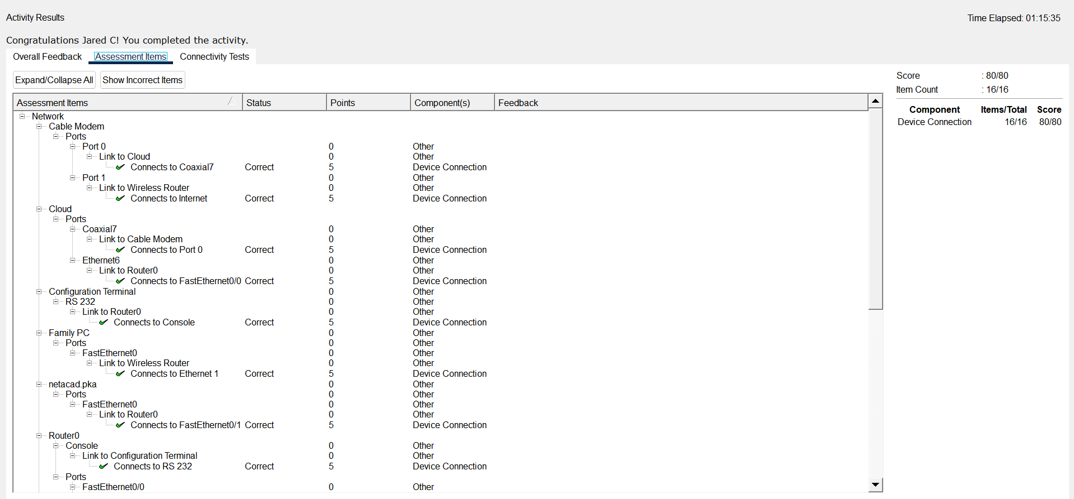
End of Document

